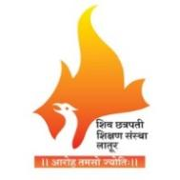

Shiv Chhatrapati Shikshan Sanstha’s

Rajarshi Shahu Mahavidyalaya (Autonomous), Latur

Department of Sanskrit

A) A Summary Report of the Activity
Competition on
Sanskrit song singing competition under the college.
Date: 28.08.2023

1) Title of Programmed: |  | District Level Sanskrit song singing competition.
2) Name of Organizing Department/Unit: |  | Rajarshi Shahu Mahavidyalaya (Autonomous), Latur- Department of Sanskrit, Maharashtra.
3) Name of the Coordinator(s)/ Convener(s)/  Organizer(s) of the programmer: |  | Programme Coordinator: 1) Dr. R. K. Arya
4) Date(s) of the Programmer: |  | 28.08.2023
5) Venue/Mode:- |  | Department of Sanskrit, Rajarshi Shahu Mahavidyalaya (Autonomous), Latur.  Place- V.L.C Hall, Date- 28.08.2023,  Time- 10.00 Am  Offline Platform
6) Target Group: |  | 01th to U.G Students.
7) Number of Participants: |  | Male | Female | Total
A separate list with signatures be maintained in the department/Unit) | Students | 15 | 27 | 42
 | Teaching | 05 | 06 | 11
 | Total | Offline Mode |  | 53
8) Chief Guest and Resource Person:  Chairperson: |  | 1) Sangit Visharad Kamalakshi Kulkarni, Latur-, Maharashtra.  2) Sangit Visharad- Gita Jaaybhaye, Latur, Maharashtra.  Dr. Mahadev Gavhane  Principal- Rajarshi Shahu Mahavidyalaya (Autonomous), Latur. Maharashtra.
9) Total Expenditure for the Programmer |  | 8000
10) Source of Funding: |  | Rajarshi Shahu Mahavidyalaya (Autonomous), Latur.

C) Geo-tagged Photographs/Screenshots
Brochure Prepared for the Programmer | This Certificate was given to the Students.
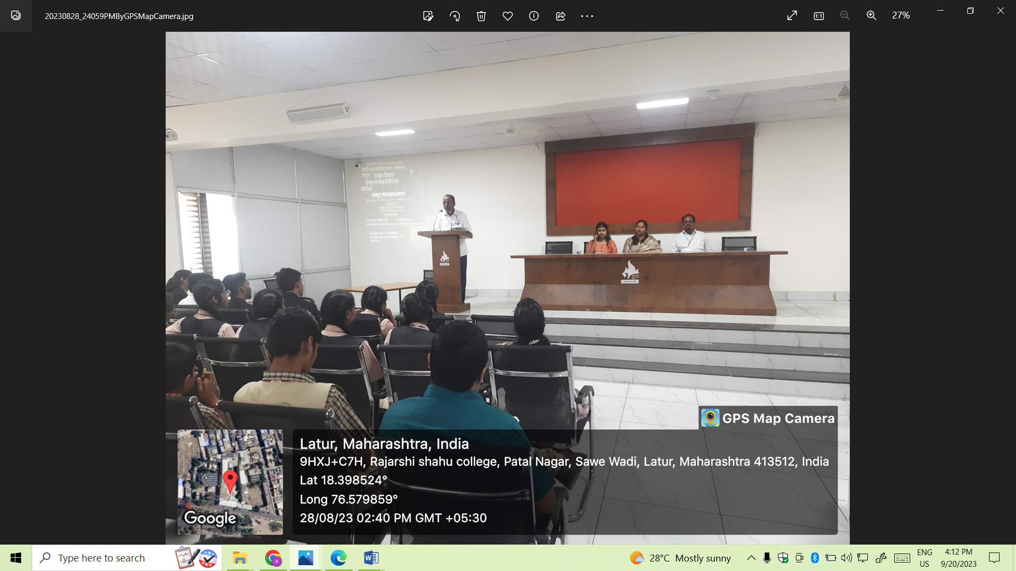  Head of Sanskrit Department (Asso. Prof. R.K.Arya) Introducing the program. | 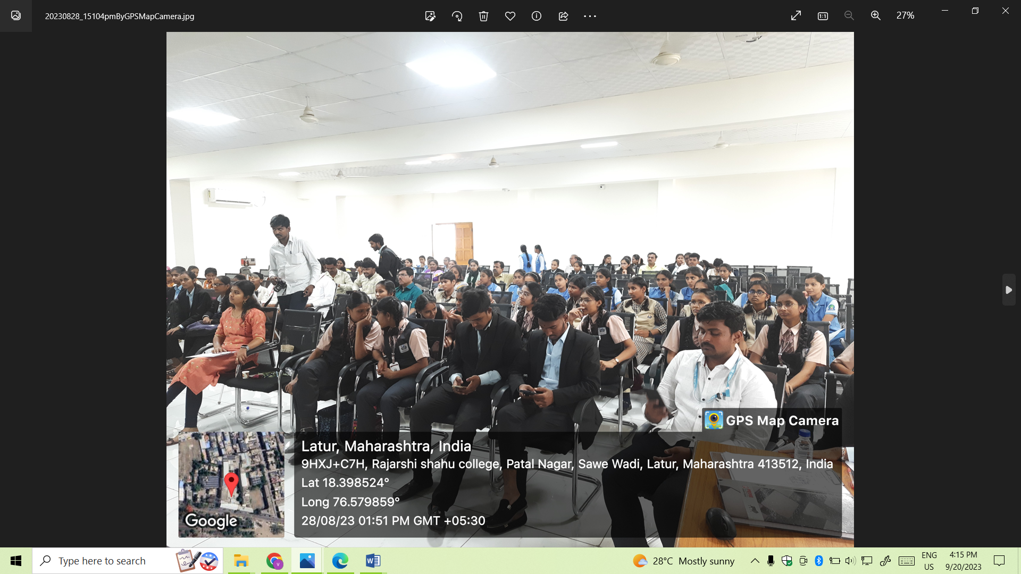  All the students listening attentively and enjoying the program.
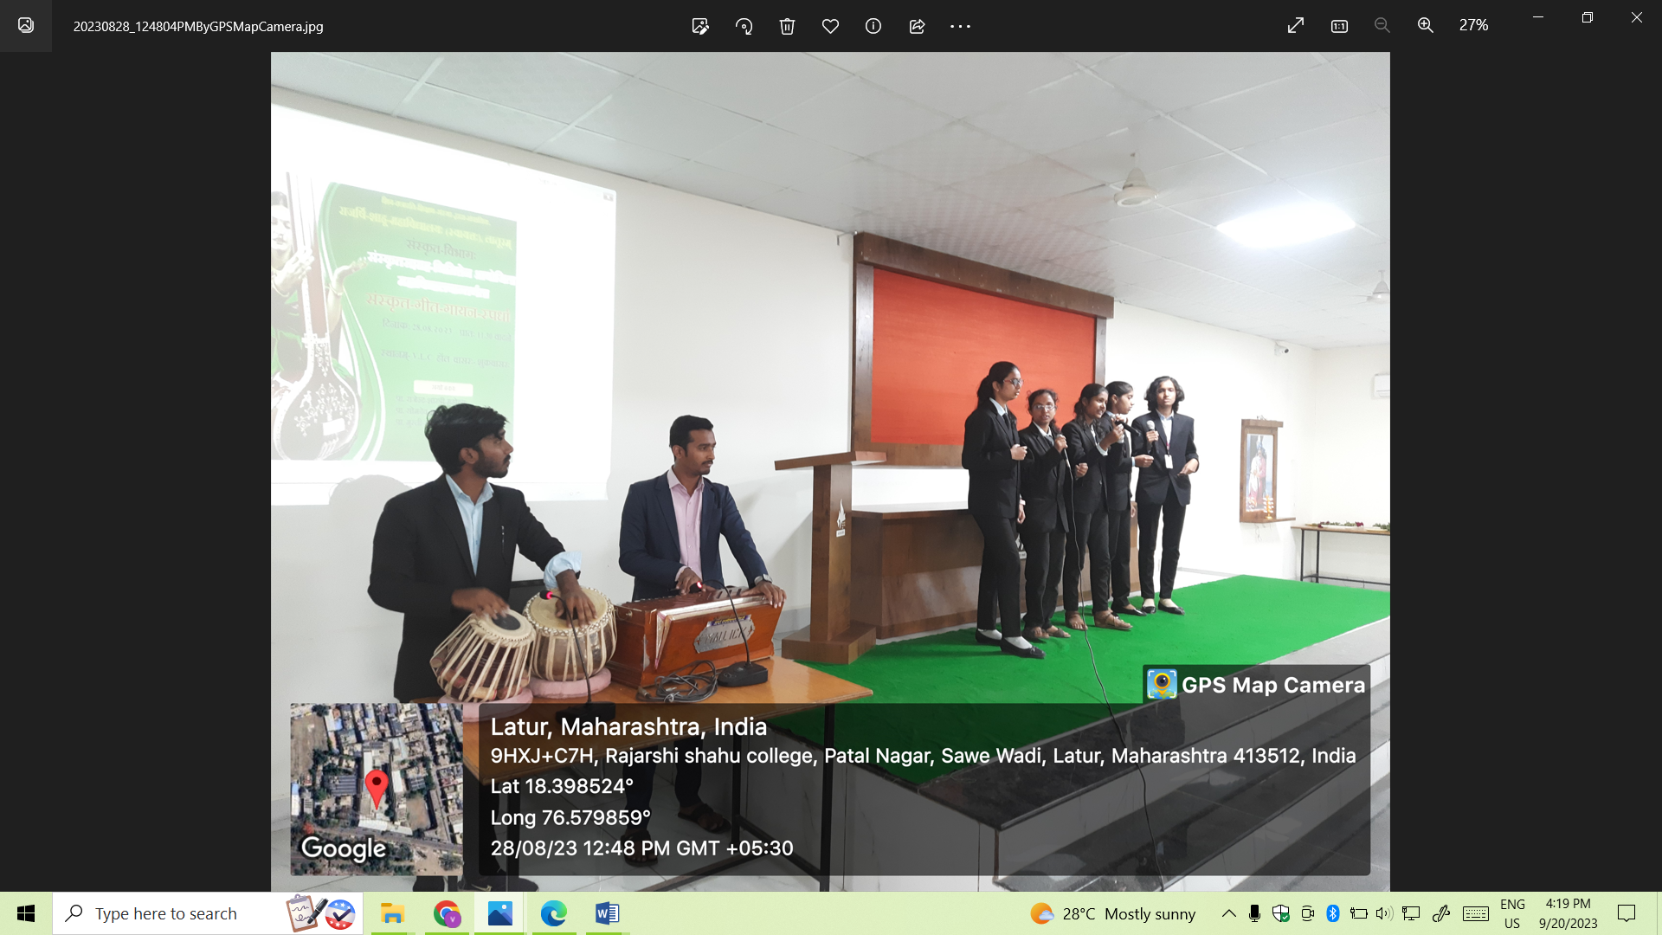  Students presenting a Sanskrit Song during the Competition. | 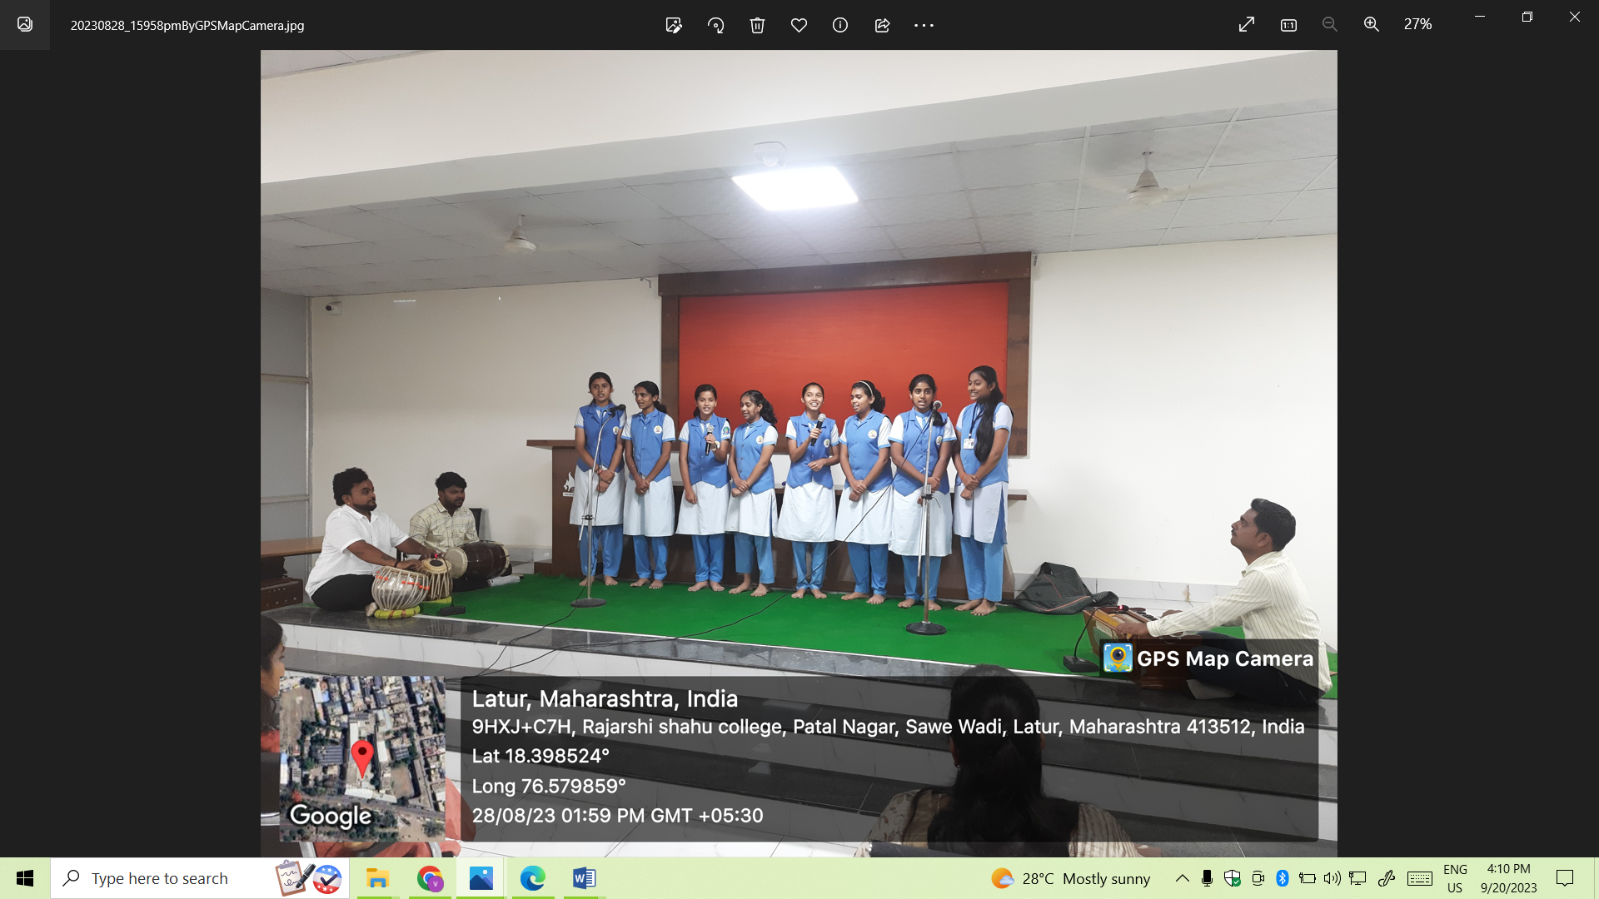  Student presenting a Sanskrit Song during the Competition.
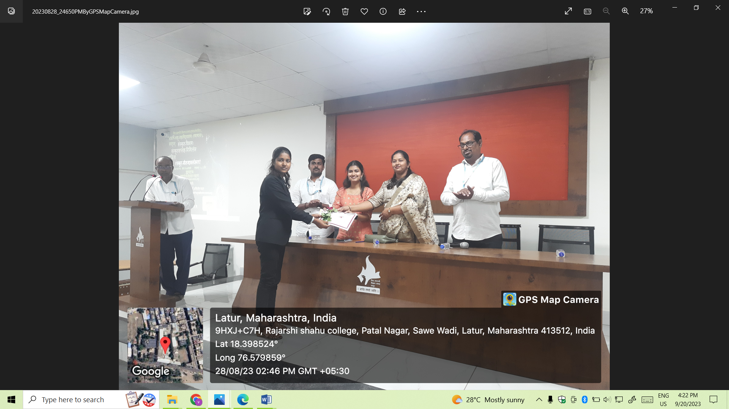  Guests distributing prizes to students in the competition. | 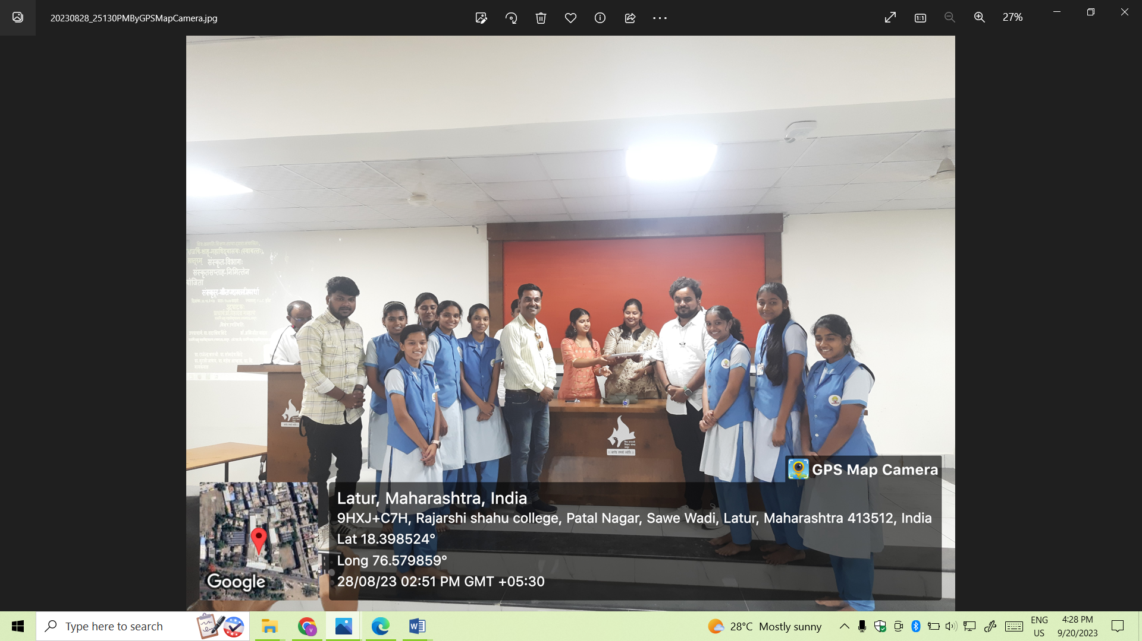  Guests distributing prizes to students in the competition.

D) Copies of Brochure Prepared for the Programmer:-

E) Link of Video of the Programme: - Nil.

F) Any other Publicity Material: - Nil.

Attendance List: -

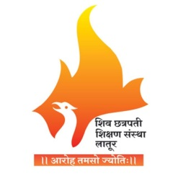

Rajarshi Shahu Mahavidyalaya (Autonomous), Latur.

Department of Sanskrit
List of Participant.
Date: 28/08/2023

