M Sc First Year Semester II
Dr Deepak V Vedpathak

Transformation

Griffith Experiment & Transforming Principle
Griffith experiment was a stepping stone for the discovery of genetic material. Frederick Griffith experiments were conducted with Streptococcus pneumoniae.
During the experiment, Griffith cultured Streptococcus pneumoniae bacteria which showed two patterns of growth. One culture plate consisted of smooth shiny colonies (S) while other consisted of rough colonies (R). The difference was due to the presence of mucous coat in S strain bacteria, whereas the R strain bacteria lacked them.
Experiment: Griffith injected both S and R strains to mice. The one which was infected with the S strain developed pneumonia and died while that infected with the R strain stayed alive.
In the second stage, Griffith heat-killed the S strain bacteria and injected into mice, but the mice stayed alive. Then, he mixed the heat-killed S and live R strains. This mixture was injected into mice and they died. In addition, he found living S strain bacteria in dead mice.
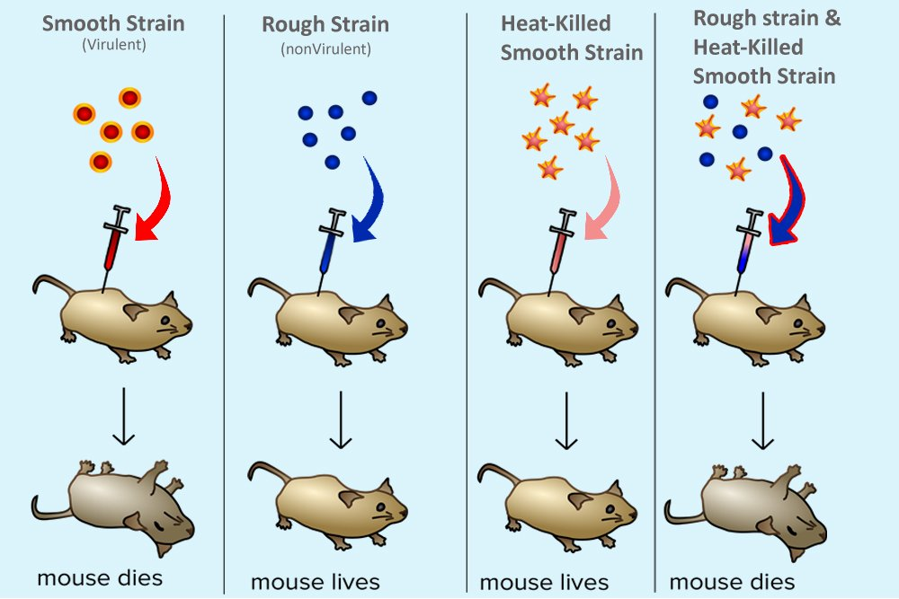

Conclusion: Based on the observation, Griffith concluded that R strain bacteria had been transformed by S strain bacteria. The R strain inherited some ‘transforming principle’ from the heat-killed S strain bacteria which made them virulent. And he assumed this transforming principle as genetic material.

DNA as Genetic Material
Griffith experiment was a turning point towards the discovery of hereditary material. However, it failed to explain the biochemistry of genetic material. Hence, a group of scientists, Oswald Avery, Colin MacLeod and Maclyn McCarty continued the Griffith experiment in search of biochemical nature of the hereditary material. Their discovery revised the concept of protein as genetic material to DNA as genetic material.
Avery and his team extracted and purified proteins, DNA, RNA and other biomolecules from the heat-killed S strain bacteria. They discovered that DNA is the genetic material and it is alone responsible for the transformation of the R strain bacteria. They observed that protein-digesting enzymes (proteases) and RNA-digesting enzymes (RNases) didn’t inhibit transformation but DNase did. Although it was not accepted by all, they concluded DNA as genetic material.
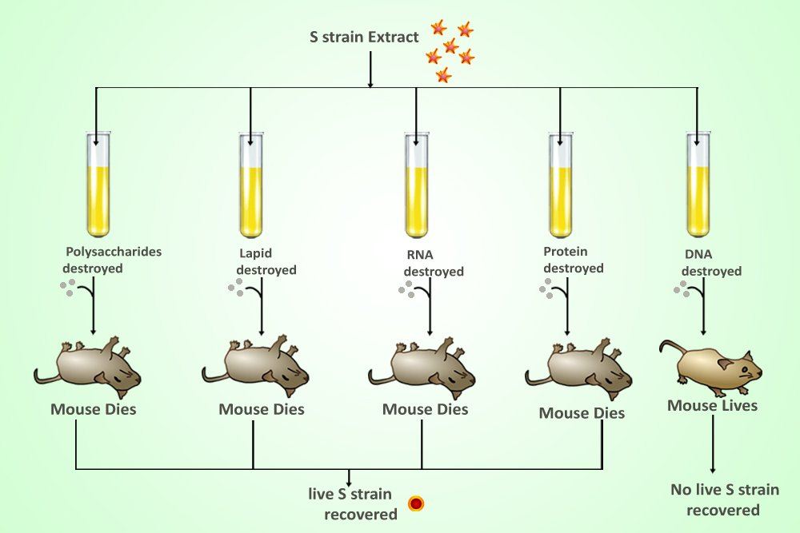

Transformation is the unidirectional transfer of exogenous DNA from environment into recipient cell.
It is one of the three forms of horizontal gene transfer. Transformation is the first form of genetic exchange identified in bacteria.
The exogenous DNA may or may not integrate in recipient cell chromosome and even may or may not express phenotypically.
Bacterial transformation was first observed by Frederick Griffith (1928) and stated that the transforming principle was probably a protein structure.\
After sixteen years later Oswald Avery, Colin McCleod and Maclyn MacCarty confirmed that DNA was responsible for the genetic change that was observed by Griffith.
Native bacterial chromosomal fragments, plasmids, bacteriophage DNA as well as genetically constructed chimeric molecules can be used for transformation.
The cells that have undergone transformation are called transformants.
Bacterial transformation can be used to map the genes of certain bacterial species in which mapping by conjugation or transduction is not possible.
In mapping experiments using transformation, DNA from a donor bacterial strain is extracted, purified, and broken into small fragments.

This DNA is then added to recipient bacteria with a different genotype.

If the donor DNA is taken up by a recipient cell, undergo recombination with the homologous parts of the recipient’s chromosome producing a recombinant chromosome.

Competence: Ability of a bacterium to take up the exogenous DNA from its environment.
It is a limiting factor in the yield of transformants because a very few bacteria are naturally competent. Competence can be artificially developed in non competent cells.
Natural competence: Some bacteria are naturally able to take up DNA and be transformed genetically by it. Few examples of naturally competent bacteria are Acinetobacter calcoaceticus, Neisseria meningitides, Neisseria gonorrhoeae, Haemophilus influenza, Azotobater agilis, Pseudomonas stutzeri Bacillus subtilis, Clostridium perfringens, Mycobacterium species and Streptomyces species.
Development of competence is depend on the physiological state of bacterial cell cycle and also on cell density. In Bacillus subtilis the development of competence occurs at the end of logarithmic growth phase where the cells reach at high density.
In some bacteria the competence is observed when cells are shifted from optimum growth condition to poor growth conditions.

It is observed that competence was established in Pneumococcus culture after 90 to 100 minutes of beginning the culture and last up to 7 to 15 minutes while in Bacillus subtilis competence lasts usually for several hours.

Competent cells produce a protein that can be isolated and used to confer competence on other cells. The protein (enzyme) is possibly being a component of the membrane which catalyzes the uptake of DNA by degrading some component of the cell surface and exposing the receptor for exogenous DNA.

In the Neisseria and related bacteria competence express constitutively while in other bacteria the development of competence is genetically regulated.

Mechanism of competence generation in Bacillus subtilis by Quorum sensing:

At the end of logarithmic growth phase, the exhaustion of vital nutrients in the medium results in the operation of two separate pathways (which sense the cell density) which leads to the expression of specific set of genes (com genes). Products of these com genes are essential for development of competence.

The com X gene of an actively growing cell produces a precursor ComX molecule in the cytoplasm. The ComQ protein processes and modifies the precursor ComX to a smaller, active peptide, a competence factor, called ComX (Pheromone- a hormone) which is released in the cell’s environment. At high cell densities, high levels of ComX are present in the population.

The high levels of ComX in the environment are sensed by a molecular communication system called as a two component signal transduction system. This system is comprise of ComP and ComA proteins. Comp is a sensor- kinase protein which spans the membrane in such a way that its half portion expose to the outer environment and half part remains exposed to the cytoplasm. The ComX present in environment binds to the externally exposed part of the ComP. A series of phosphorelation and dephosphorelation of ComP pass the information in the form of signal to ComA (a response regulator protein) which undergo phosphorylation. The phosphorylated ComA promots the transcription of srf operon. (operon for synthesis of a lipopeptide antibiotic surfactin). The ComS gene (a part of srf operon) produce ComS protein that activates ComK which leads to the induction of competency genes.

A PhrC gene produces PhrC protein in cytoplasm which is processed and modified to CSF (competence stimulating factor). The CSF protein is excreted out of the cell and again passed through the membrane protein channel called SpoOk permease. In the cytoplasm the SRF convert to ComA.

Artificial competence: Many bacteria, plant or animal cells are unable to take up exogenous DNA from its environment by developing natural competence. This is because these do not carry the genes that produce proteins needed for development of competence. In such cells competence can be developed artificially through physical manipulations by chemical or physical treatments. The examples of such bacteria are Escherichia coli and Salmonella typhimurium.

The divalent cation method: The E. coli cells are exposed to divalent cations such as calcium chloride at a very cold temperature (0ºC). It is followed by addition of free DNA and a heat shock at 42ºC. By this method approximately 1% of cell population may become competent.

Electroporation method: Both, prokaryotic as well as eukaryotic cells can be subjected to a high voltage electricity (~1 to 5 kilovolts). It creates temporary pores in cell membrane making it permeable to DNA and protein molecules.

Polyethylene glycol method: The treatment of gram positive bacteria like B. subtilis with propylene glycol (PEG6000) is responsible for removal of peptidoglycan layer (cell wall) and protoplasts are produced. These protoplasts are able to take up plasmid or bacteriophage DNA. The protoplasts are suspended in an osmotically stabilized environment in which the cell wall regeneration takes place. About 80% viable cells can be made competent by this method in a well established system. Any cell, including cell wall less organisms such as Mycoplasma and L-forms, which are otherwise reluctant to any type of genetic exchange, can me made competent and hence vulnerable to transformation.

Only a small proportion of the cells involved in transformation actually take up DNA. Consider an example of the transformation of B. subtilis . (Other systems may differ in the details of the process.) The donor double-stranded DNA fragment is wild type (a ) for a mutant allele a in the recipient cell . The two DNA strands are shown in the figure and, because subsequent stages of transformation involve unusual strand pairing, each DNA strand is labeled with an allele. During DNA uptake, one of the two DNA strands is degraded, so only one intact linear DNA strand is left inside the cell. This single linear strand + pairs with the homologous DNA of the recipient cell’s circular chromosome to form a triple-stranded region . Recombination then occurs by a double crossover event involving the single-stranded DNA strand of the donor and the double-stranded DNA of the recipient. The result is a recombinant recipient chromosome: In the region between the two crossovers, one DNA strand has the donor a+ DNA segment, and the other strand has the recipient a DNA segment.
In other words, in that region, the two DNA strands are part donor, part recipient, for the genetic information. A region of DNA with different sequence information on the two strands is called heteroduplex DNA. The other product of the double crossover event, a single-stranded piece of DNA carrying an a DNA segment, is degraded. After replication of the recipient chromosome, one progeny chromosome has donor genetic information on both DNA strands and is an a transformant . The other progeny chromosome has recipient genetic information on both DNA strands and is an a nontransformant. Equal numbers of a transformants and a nontransformants are produced. Given highly competent recipient cells, the transformation of most genes occurs at a frequency of about 1 cell in every 103 cells.
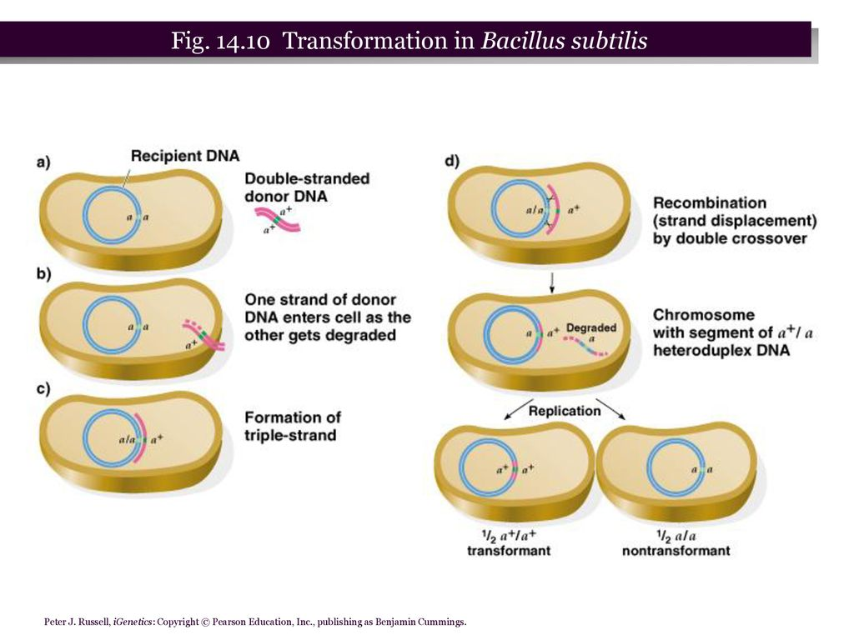
Transformation can be used to determine whether genes are linked (in this case, meaning physically close to one another on the single bacterial chromosome), to determine the order of genes on the genetic map, and to determine map distance between genes. The principles of determining whether two genes are linked are as follows:
The efficient transformation of DNA involves fragments with a size sufficient to include only a few genes. If two genes, x and y , are far apart on the donor chromosome, they will always be found on different DNA fragments.
Thus, given an x y donor and an x y recipient, the probability of simultaneous transformation (cotransformation) of the recipient to x y (from the product rule) is the product of the probability of transformation with each gene alone. If transformation occurred at a frequency of 1 in 103 cells per gene, x y transformants would be expected to appear at a frequency of 1 in 106 recipient cells. So if two genes are close enough that they often are carried on the same DNA fragment, the cotransformation frequency would be close to the frequency of transformation of a single gene. As determined experimentally, if the frequency of cotransformation of two genes is substantially higher than the products of the two individual transformation frequencies, the two genes must be close together.
Gene order can be determined from cotransformation data . If genes p and q are often transmitted to the recipient together, then these two genes must be closely linked. Similarly, if genes q and o are often transmitted together, those two genes must be close to one another. To determine gene order, we now need information about genes p and o. Theoretically, there are two possible orders: p-o-q and p-q-o. If the order is p-o-q, then p and o should be cotransformed because they are more closely linked than p and q, whereas if the order is p-q-o, then p and o should be cotransformed rarely or not at all, because they are far apart. The data show no cotransformants for p and o, indicating that the gene order must be p-q-o.

